Migration Digital Resources

Send completed work to monarch.gk12@gmail.com
#1 Illegal immigration

What is your current perception of illegal immigrants from Latin America & Mexico entering the US.? Has it increased or decreased over the last 50 years? Why? What factors would impact this migration? Write at least 5 sentences here:
Now visit the following site and read the article:

http://www.utsandiego.com/news/2011/jul/07/illegal-immigration-mexico-continues-decline/

What is your new perception of illegal immigrants from Latin America & Mexico entering the US.? Has it increased or decreased over the last 50 years? Why? What factors would impact this migration? Write at least 5 sentences here
#2 US internal migration:

Use the link below and choose 4 of the 9 major cities presented and find connections to Boulder
Country. List Inbound and Outbound migration numbers of people, and average incomes to fillout this
chart:

City | Number of inbound from Boulder  Country & average income | Number of outbound from Boulder Country &  average income
http://thesocietypages.org/graphicsociology/2010/06/16/american-internal-migration/

Provide and 4 sentence explanation for the patterns and data you see:
#3European migration: Statistic data on immigrant populations 2010

Go to the wiki site below and interpret the 2010 data. Which nations have the highest level of immigrants and why?

http://en.wikipedia.org/wiki/Immigration_to_Europe
#4 China internal migration:

Read the following passage
While the eastern provinces are still the major destination for migrant workers, there appears to have
been a shift in migrant labour away from these coastal regions between 2008 and 2009. This shift is most evident in the Pearl and Yangtze River Delta areas, which absorbed 52 per cent of all migrant labour in 2008, but only 42 per cent in 2009. This was partly due to the economic effects of the global
financial crisis deterring migration towards the coast, but it could also reflect the gradual shift in economic activity towards the central and western provinces as central government policies increasingly focus on developing these regions further.
Reflecting the large share of rural migrants in coastal provinces, it appears that migrant workers are predominantly employed by the non-state sector and, in particular, by the manufacturing industry (Graphs 9 and 10). Nearly 70 per cent of migrant workers are employed in ‘private and individual’ firms, although this share appears to have declined over the past 10 years. Currently, rural migrants are estimated to account for a little over half of urban employment in private and individual firms.
View the 2 maps below and answer the following questions
Name the two provinces with the highest amount of outward migration
Name the two provinces with the highest amount of inward migration:
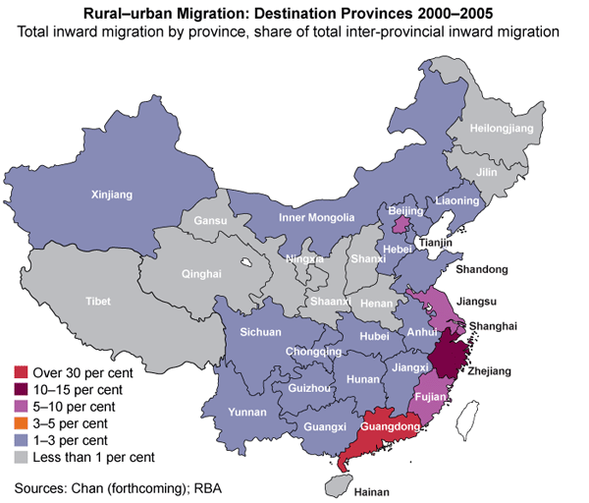
Google these provinces and make a chart with province names and unemployment figures and types of economic activity for each. Include push and pull factors for each province

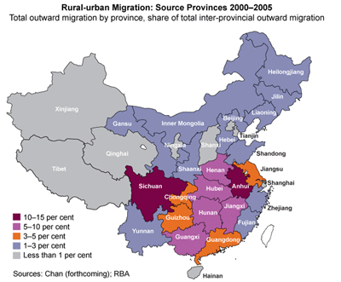
#5 Indonesia:
Examine the map of Indonesian migration below and answer the following questions:

List the provinces with significant amounts of Internally Discplaced People (IDP) List the provinces with of origin of IDP’s
Google and discover the push and pull factors for these Indonesian IDP
